**Installation of OPEN MPI on windows using cygwin**

Cygwin is:

* a large collection of GNU and Open Source tools which provide functionality similar to   a DLL (cygwin1.dll) which provides substantial POSIX API functionality.

1. Download the setup file of Cygwin from https://cygwin.com/ and run it

2. While installing , it will ask for packages to be installed. The following are packages to be installed

a. OPENMPI

b. hwloc

c. event-core

d.event-pthread

e. rsh:ssh

3. Once the installation is successful, you will be prompted with a cygwin cmd window as shown below on clicking the icon of cygwin.

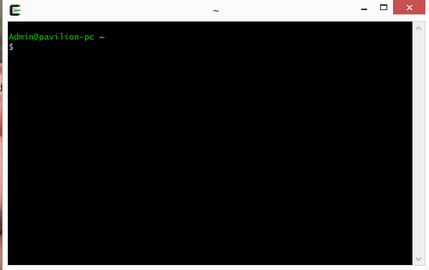

4. Create a MPI program using C language. The following are the steps of compilation and execution of a MPI program by simulating a distributed environment

